**CS3354 Software Engineering**

**Final Project Deliverable 1**

**Book Review Library**

Riya Patel

Benjamin Goff

Austin McGuire

James Castanho

Josephine Sun

Raashi Kulshrestha

**1. Please attach here the Final Project draft description** (that contains the instructor feedback). It is ok to include a picture of the original document. Address the feedback provided for your proposal by listing what you did to comply with the proposed changes/requests for additions to your project.

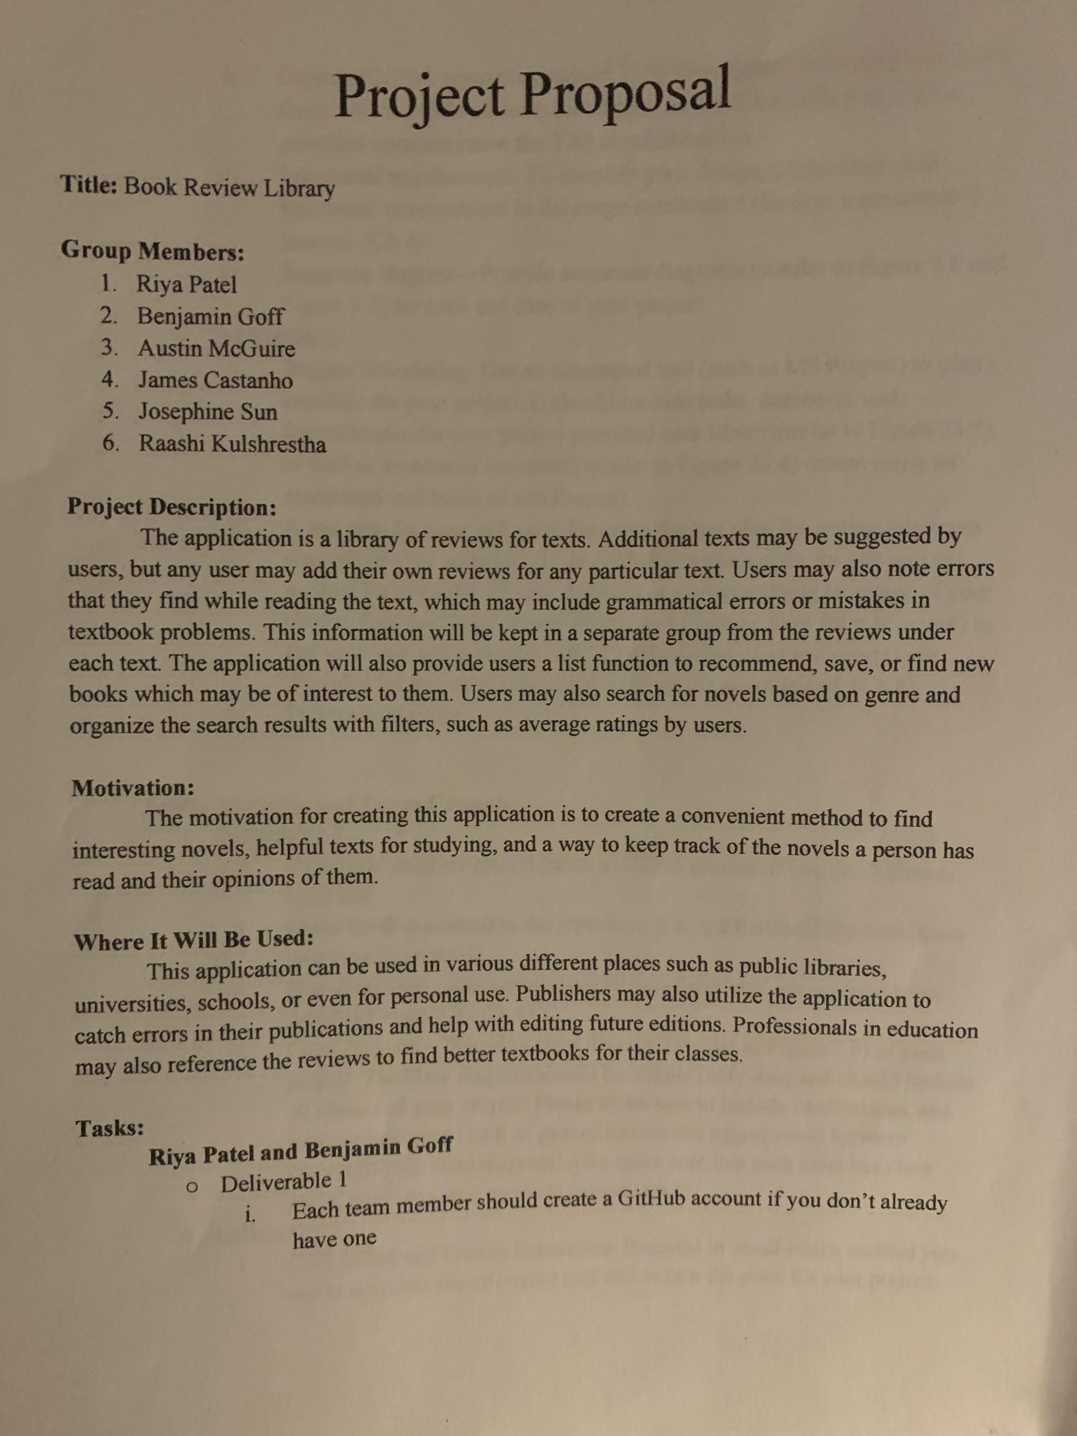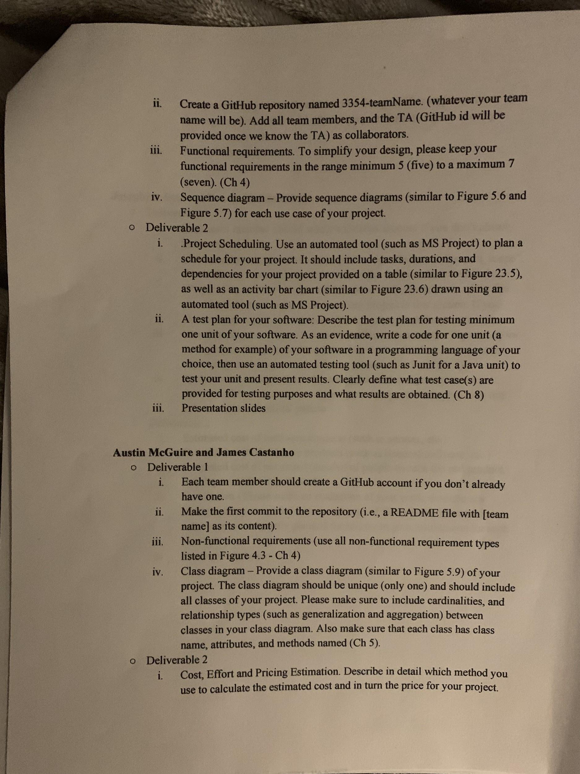

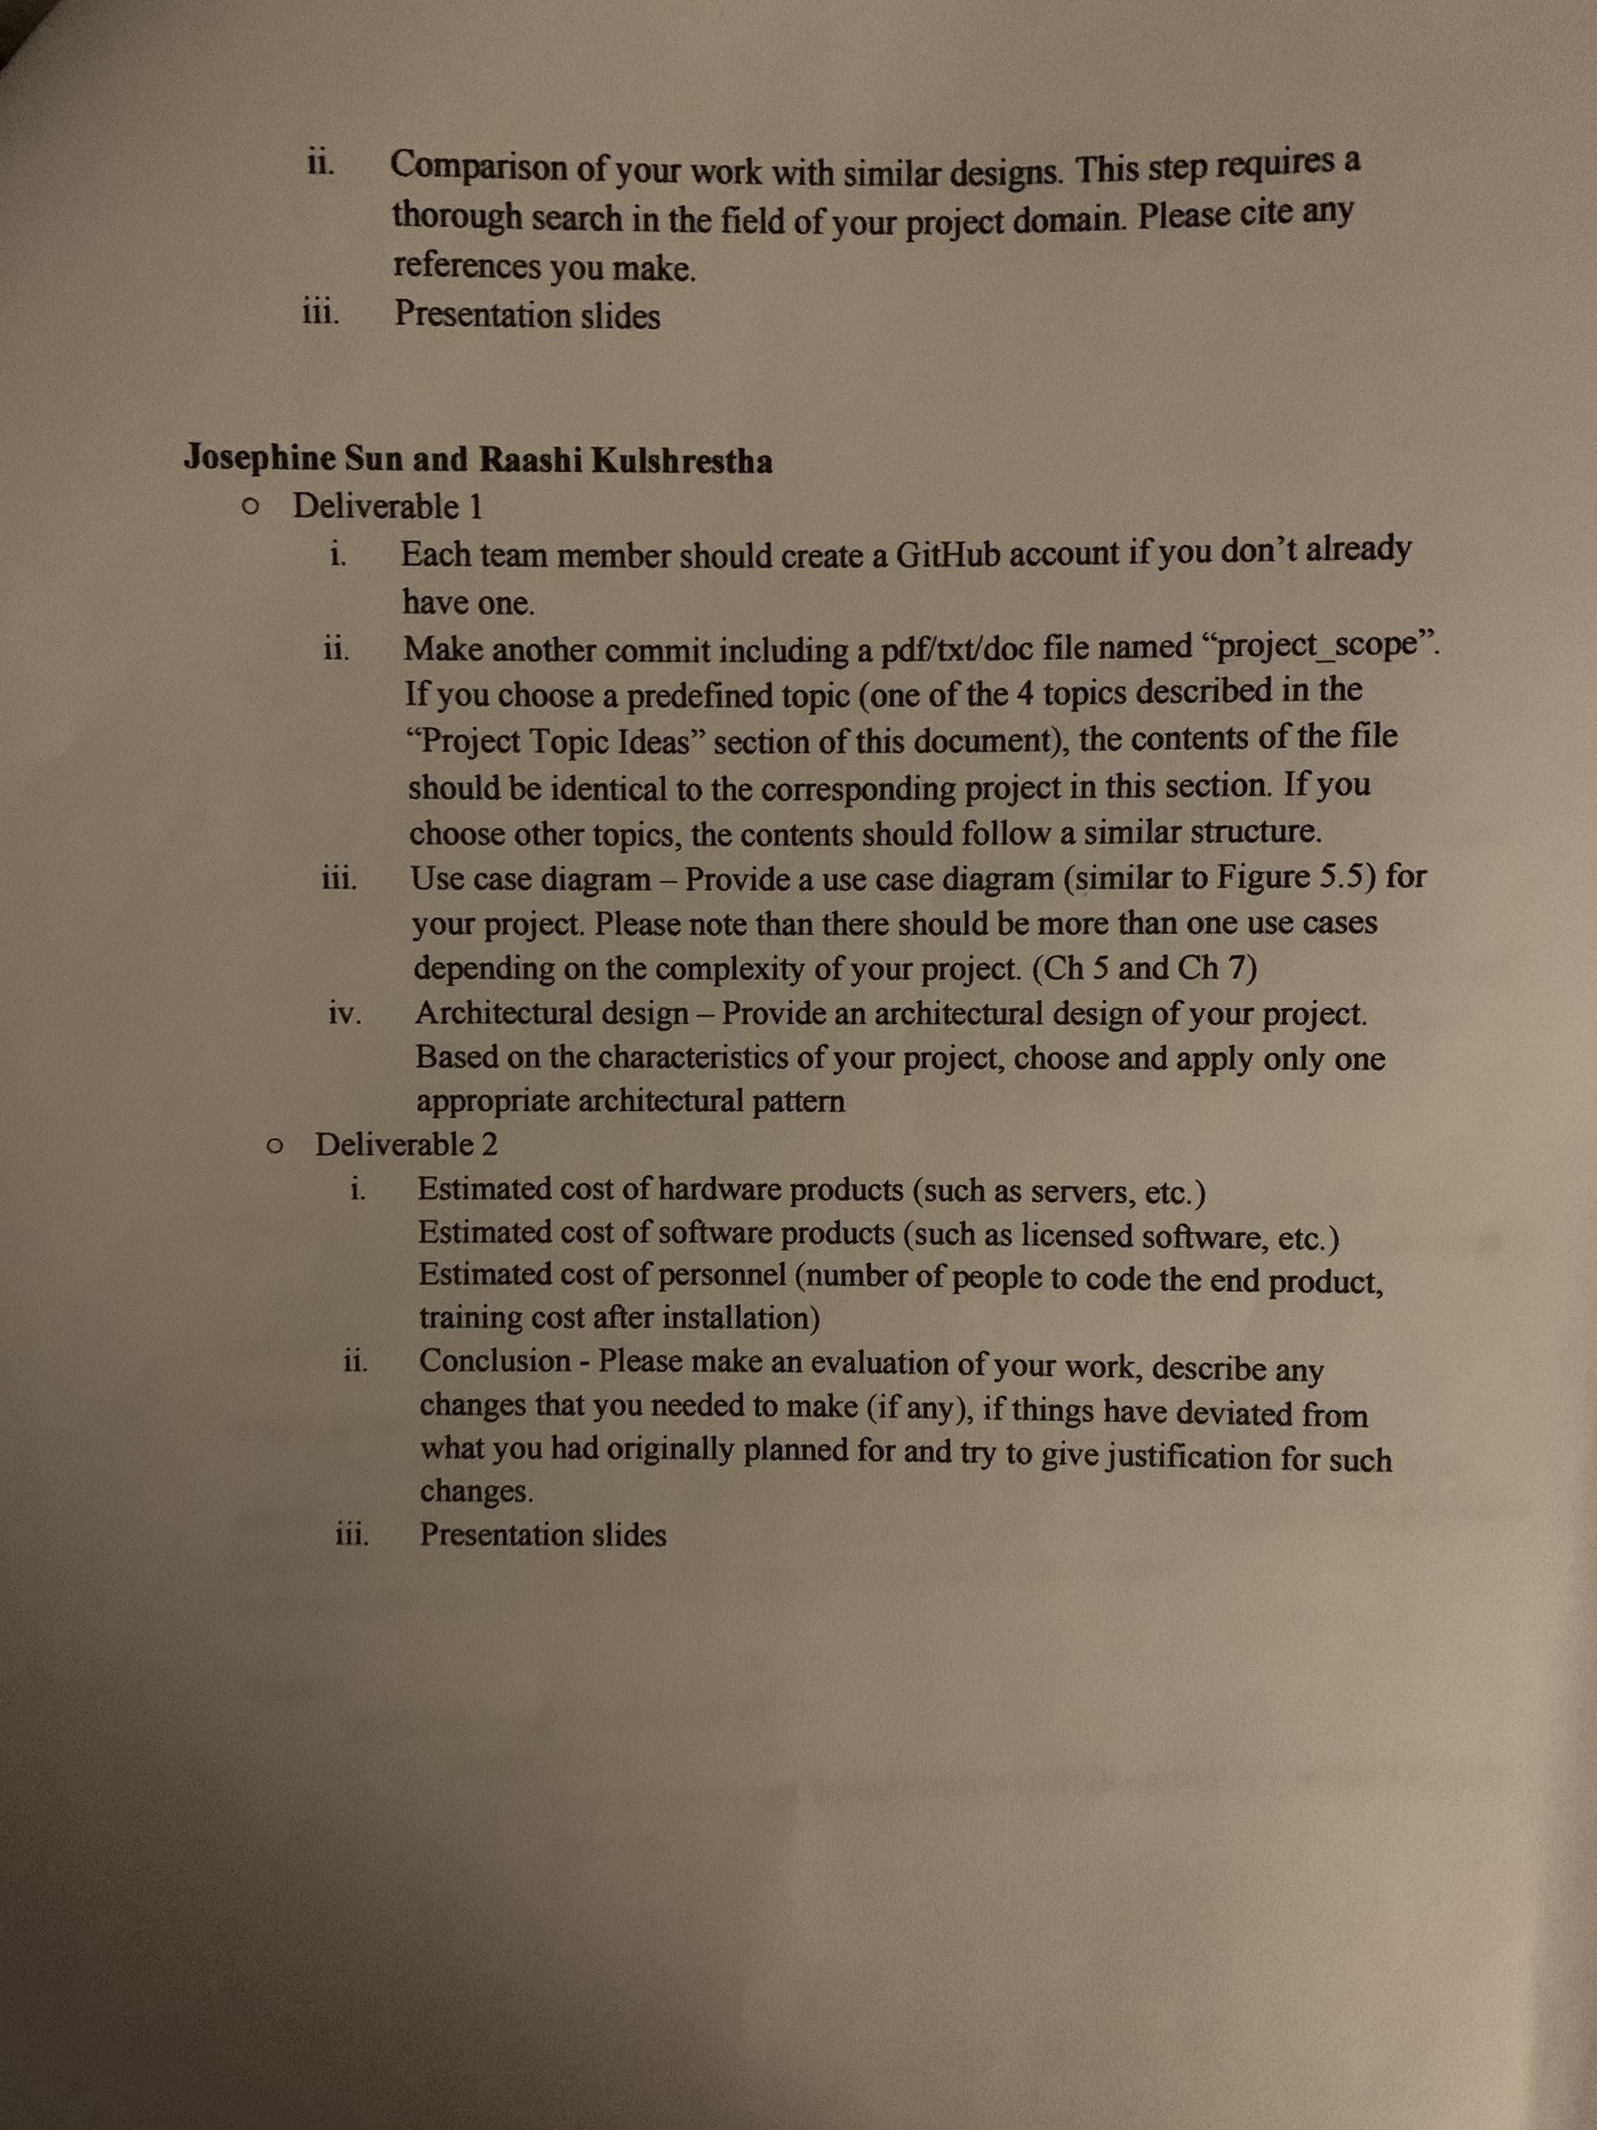

**1. Setting up a Github repository:**

<https://github.com/JosephineSun4070/3354-BookReviewLibrary>

**2. Delegation of tasks: Who is doing what**

**Riya Patel**

* + Deliverable 1
    1. Create a GitHub account.
    2. Use-Case diagram
    3. Register Sequence diagram
    4. Login Sequence diagram
    5. First Commit to Repository
  + Deliverable 2
    1. Project scheduling.
    2. Test plan.
    3. Presentation slides.

**Benjamin Goff**

* + Deliverable 1
    1. Create a GitHub account.
    2. Project Scope
    3. View List sequence diagram
    4. Create List sequence diagram
    5. Edit List sequence diagram
    6. Delete List sequence diagram
  + Deliverable 2
    1. Project scheduling.
    2. Test plan.
    3. Presentation slides.

**Austin McGuire**

* + Deliverable 1
    1. Create a GitHub account.
    2. First commit to the repository.
    3. Non-functional requirements.
    4. Class diagram.
  + Deliverable 2
    1. Cost, effort and pricing estimation.
    2. Comparison of your work with similar designs.
    3. Presentation slides.

**James Castanho**

* + Deliverable 1
    1. Create a GitHub account.
    2. Non-functional requirements.
    3. Class diagram.
  + Deliverable 2
    1. Cost, effort and pricing estimation.
    2. Comparison of your work with similar designs.
    3. Presentation slides.

**Josephine Sun**

* + Deliverable 1
    1. Create a GitHub account.
    2. Create Github Repository & add all members and TA as collaborators
    3. Architectural Design
    4. Software Process Model
    5. Search For Book Sequence Diagram
    6. Filter Book Sequence Diagram
    7. View Book Information Sequence Diagram
  + Deliverable 2
    1. Cost, effort and pricing estimation.
    2. Comparison of your work with similar designs.
    3. Presentation slides.

**Raashi Kulshrestha**

* + Deliverable 1
    1. Create a GitHub account.
    2. View Sequence Diagram
    3. Create Sequence Diagram
    4. Edit Delete Sequence Diagram
  + Deliverable 2
    1. Estimated cost of hardware products.
    2. Estimated cost of software products.
    3. Estimated cost of personnel.
    4. Conclusion.
    5. Presentation slides.

**3. Which software process model is employed in the project and why.**

The software process model that we are employing in this project is the Incremental Process Model. We are using this model because we can create a delivery of the first increment, and then add more additional features to the project over time. This process model is a desirable choice for us to use, because our project can be used by a large and diverse audience. Thus it is a good idea to select a model that would give us the ability to add and change the software after the first delivery. With this model, we can also improve the features that were developed in older version, and optimize them for the more recent scenarios in which our system is being used for.

**4.a.)** **Functional Requirements**1. User shall be able to search for a book database for a specific book by either Title, Author name, Series name, or ISBN number of the book.   
2. User shall be able to view all published reviews about chosen book (with reviews with the most likes at the top of the list).   
3. User shall be able to type a review and add it to the list of reviews.   
4. User shall be able to "like" certain reviews.   
5. Each user using the system shall be uniquely identified by a chosen username.  
6. Each user shall access the system by entering their user name and chosen password.   
7. Each user should be able to search for other users by username, and view all reviews published by that user.

**4.b.) Non-Functional Requirements**

* Product Requirements
  + Usability
    - App shall be available for Android and iOS phones.
    - App shall be available in the following languages:
      * Mandarin
      * Spanish
      * English
      * Hindi
      * Bengali
      * Portuguese
      * Russian
      * Japanese
      * French
      * German
    - App shall be accessible to users with poor eyesight or colorblindness.
    - No tutorial should be required prior to use, but will be available by request.
  + Efficiency
    - Performance
      * App must launch in less than 2 seconds.
      * Search results must return within 2 seconds of request.
      * App should not crash or have any bugs that would reduce functionality.
      * Service should be available to 10,000 concurrent users within a 5 second timeframe.
    - Space
      * File size of App should not exceed 30 MB.
  + Dependability
    - Downtime/Maintenance should not last more than 3 hours per week.
    - Downtime/Maintenance should be done during off-peak hours (~3AM)
    - Database should be backed up during downtime/maintenance.
  + Security
    - End users’ data shall be encrypted.
    - User data is confidential, will not be sold to 3rd parties.
* Organizational Requirements
  + Environmental
    - All communication with stakeholders will be through paperless communications.
  + Operational
    - End users must log in to the App via unique username and password
    - Each End User may only create one review for each book.
    - End Users may like or dislike other User reviews only once per review.
  + Development
    - Code will be written in the Java programming language
    - App will be designed according to the MVC software architecture pattern
* External Requirements
  + Regulatory
    - App will abide by all laws and regulatory requirements where its services will be available.
  + Ethical
    - Reviews will be moderated to ensure legitimacy/appropriateness of user reviews.
  + Legislative
    - Safety
      * App shall not have any vulnerabilities which would compromise the end user’s mobile device or computer.

**5. Use case diagram:**

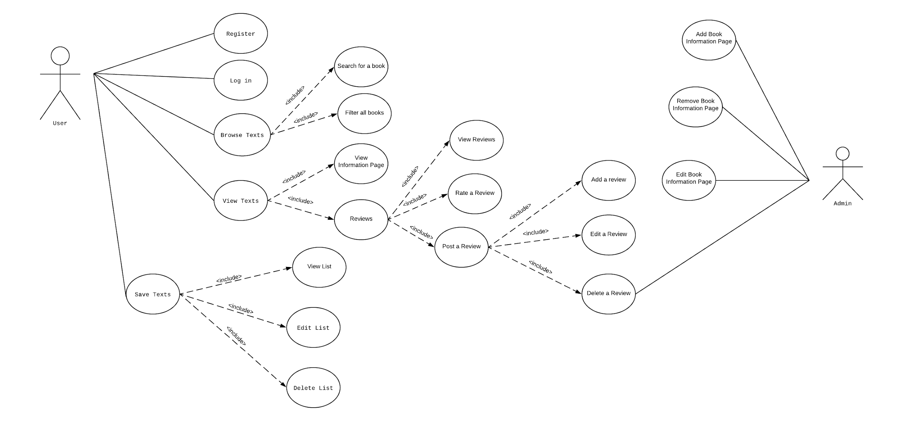

**6. Sequence diagram:**

1. **Register**

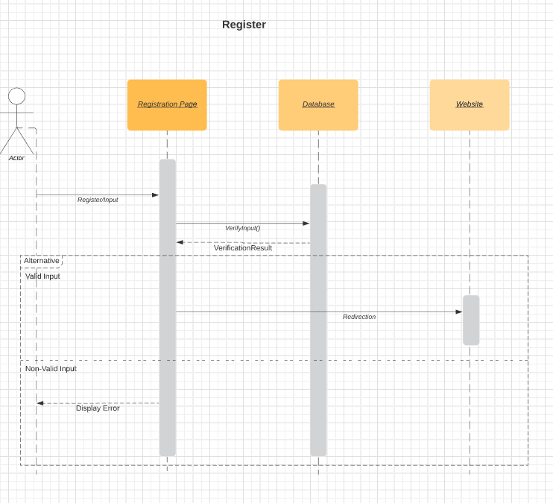

1. **Login**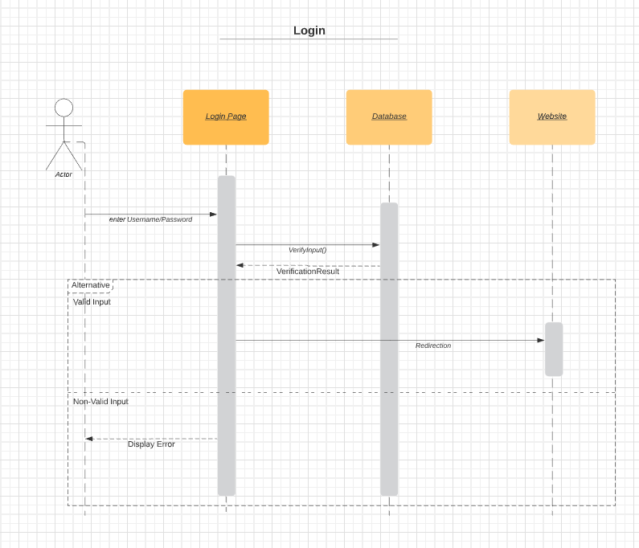
2. **Search for book**

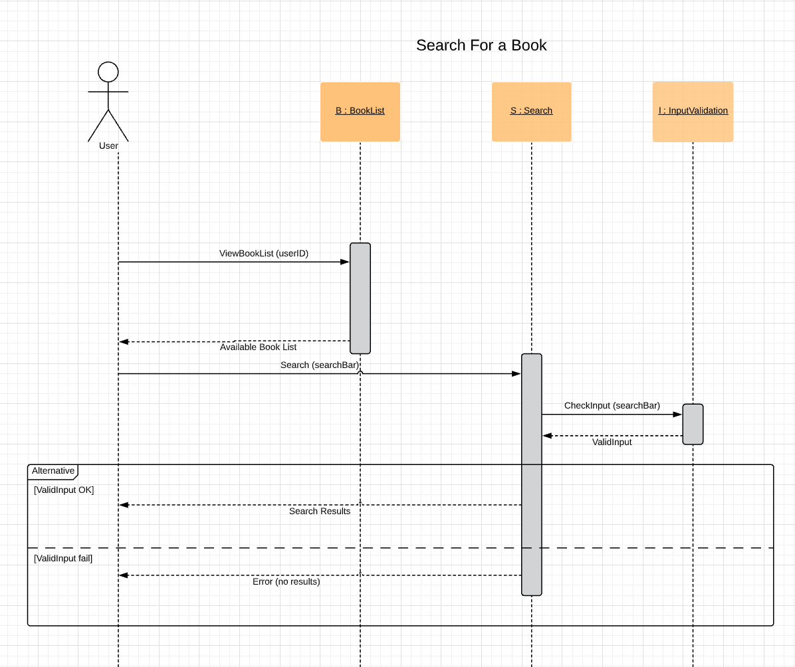

1. **Filter books**

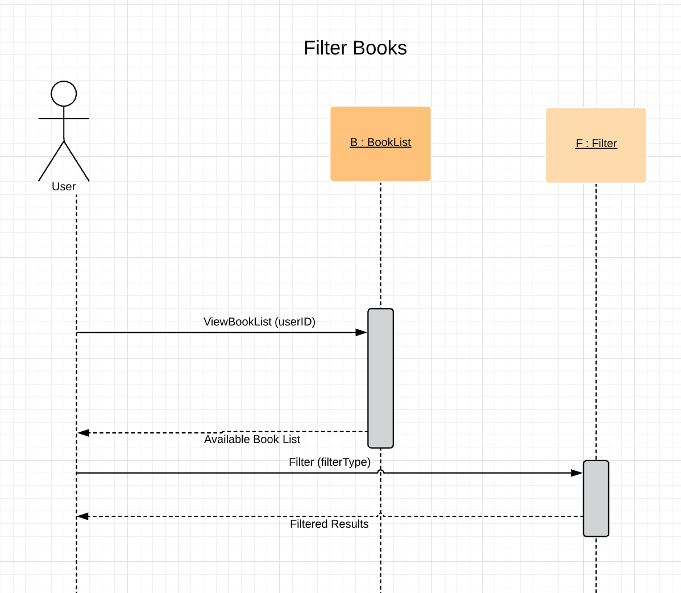

1. **View info page**

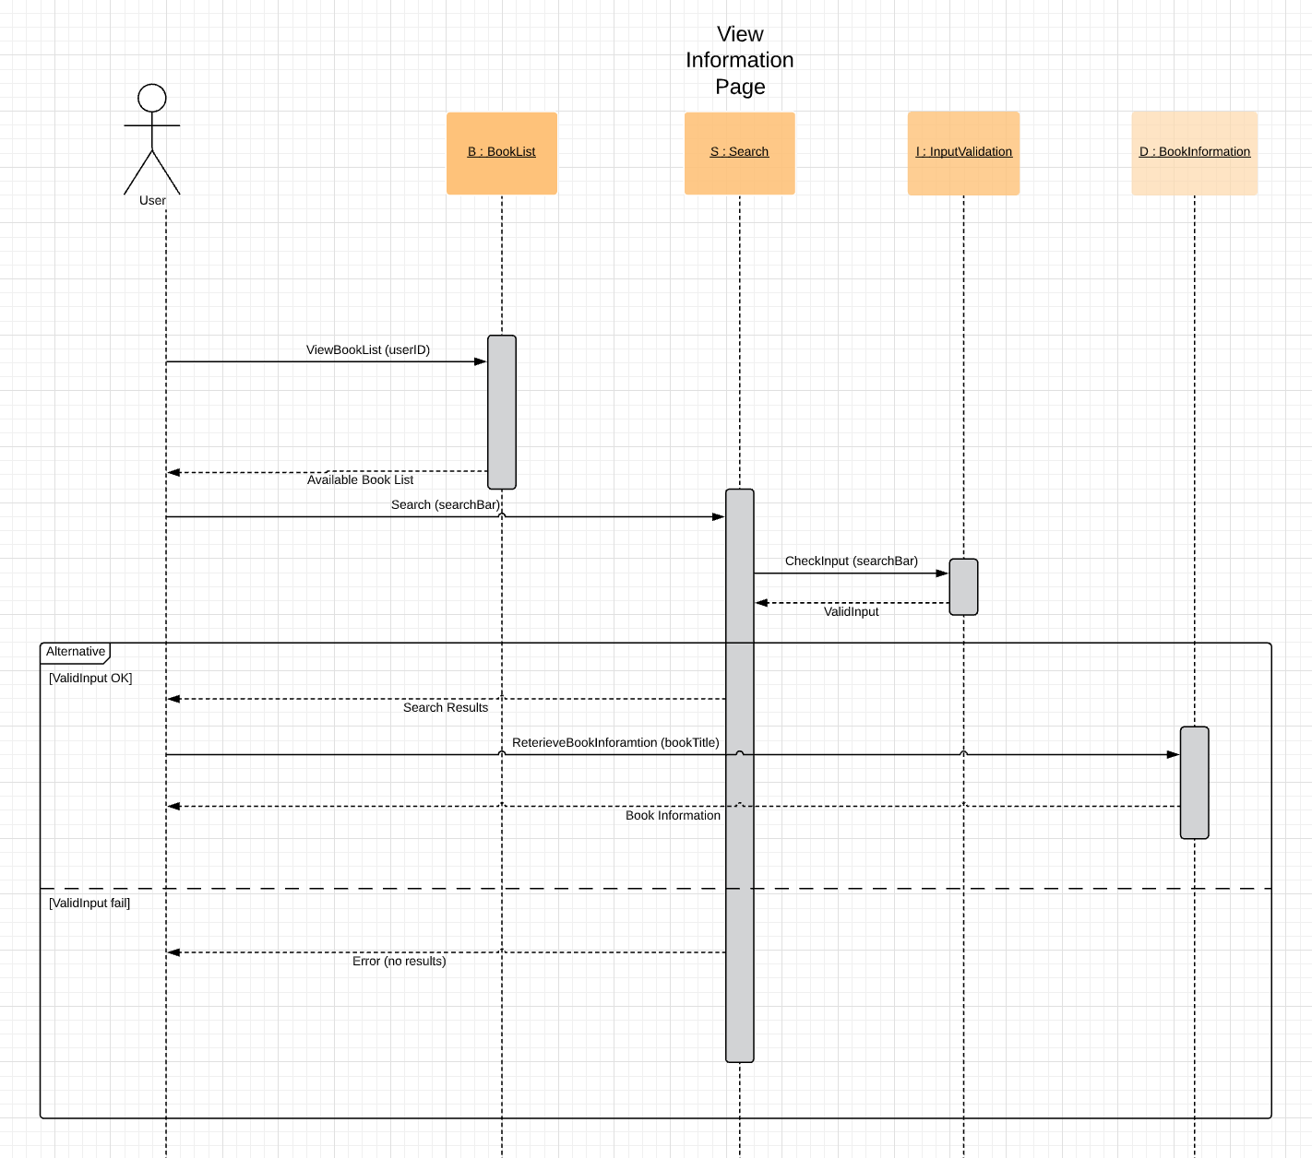

1. **View reviews**

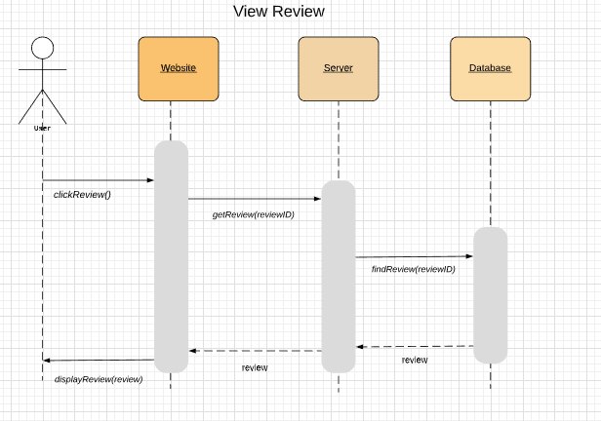

1. **Create reviews**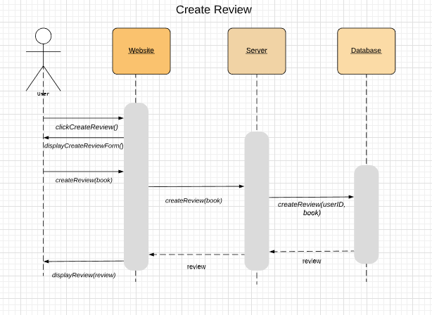
2. **Edit reviews**

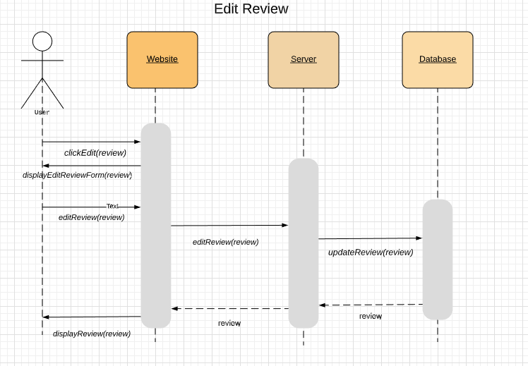

1. **Delete reviews**

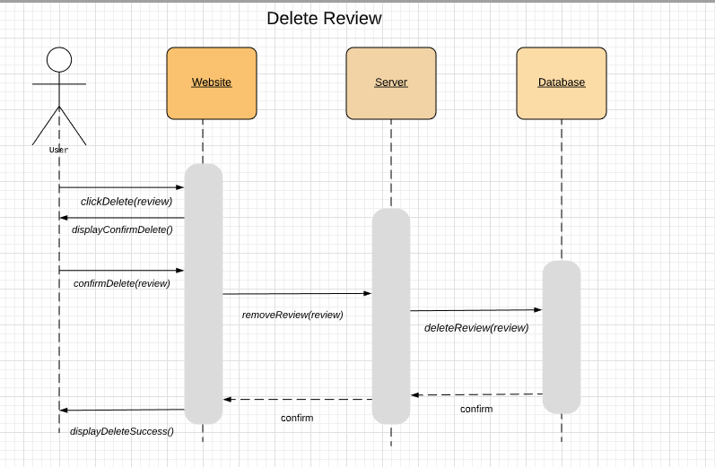

1. **View List**

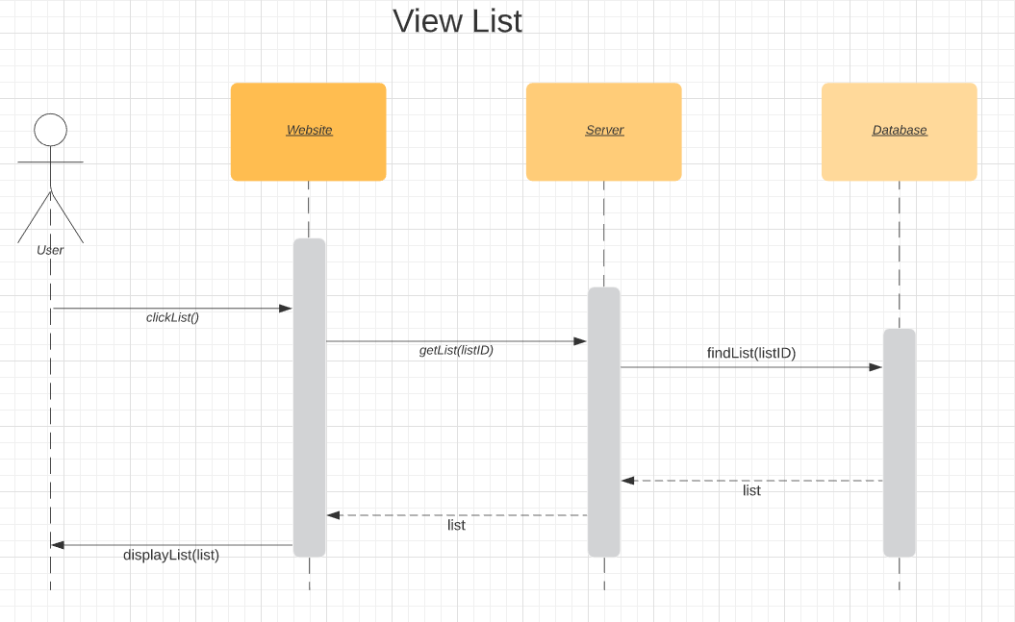

1. **Create List**

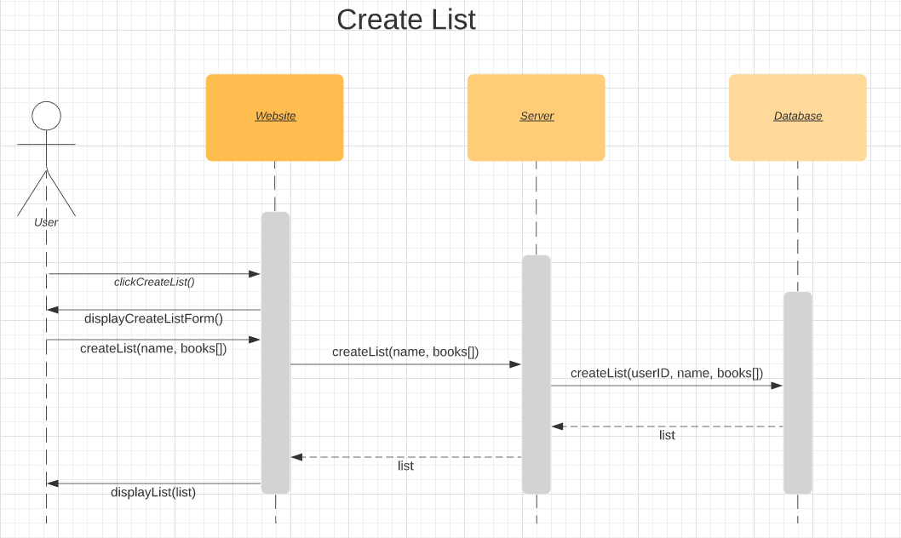

1. **Edit List**

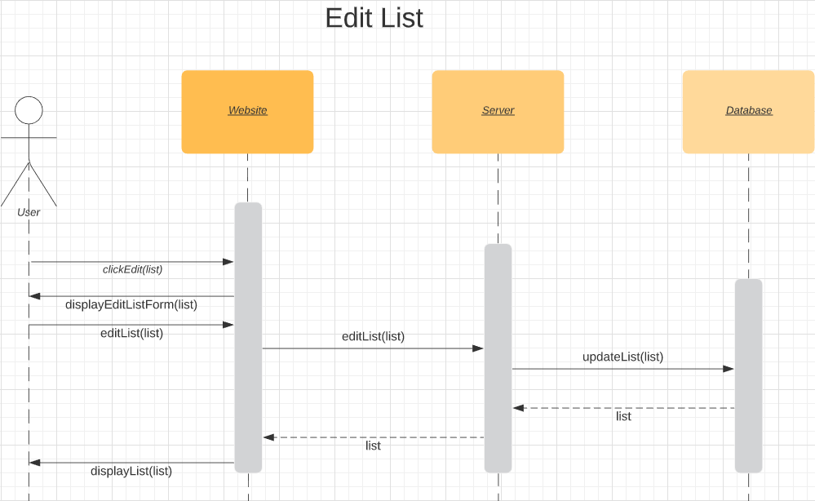

1. **Delete List**

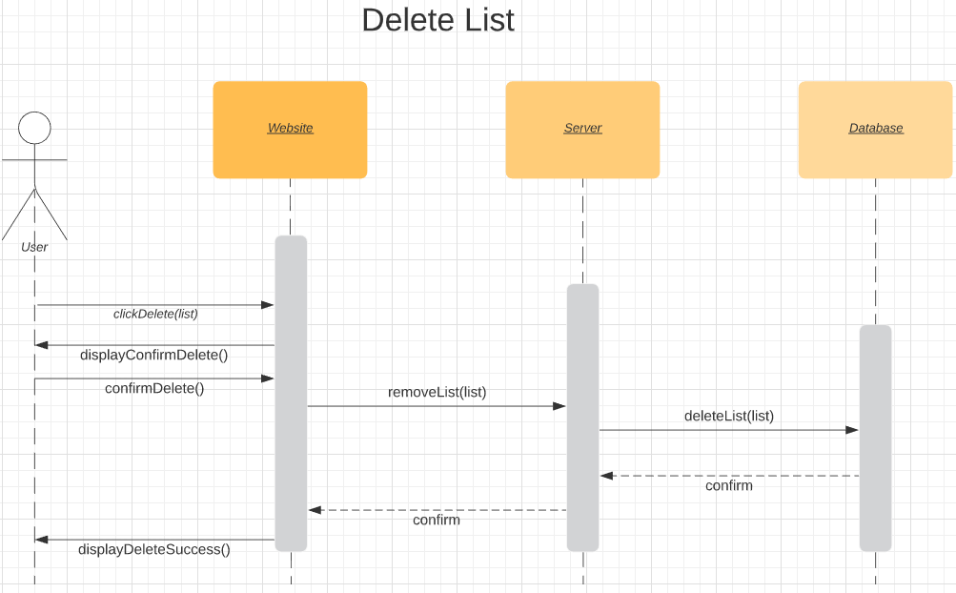

1. **Add Books/Admin**

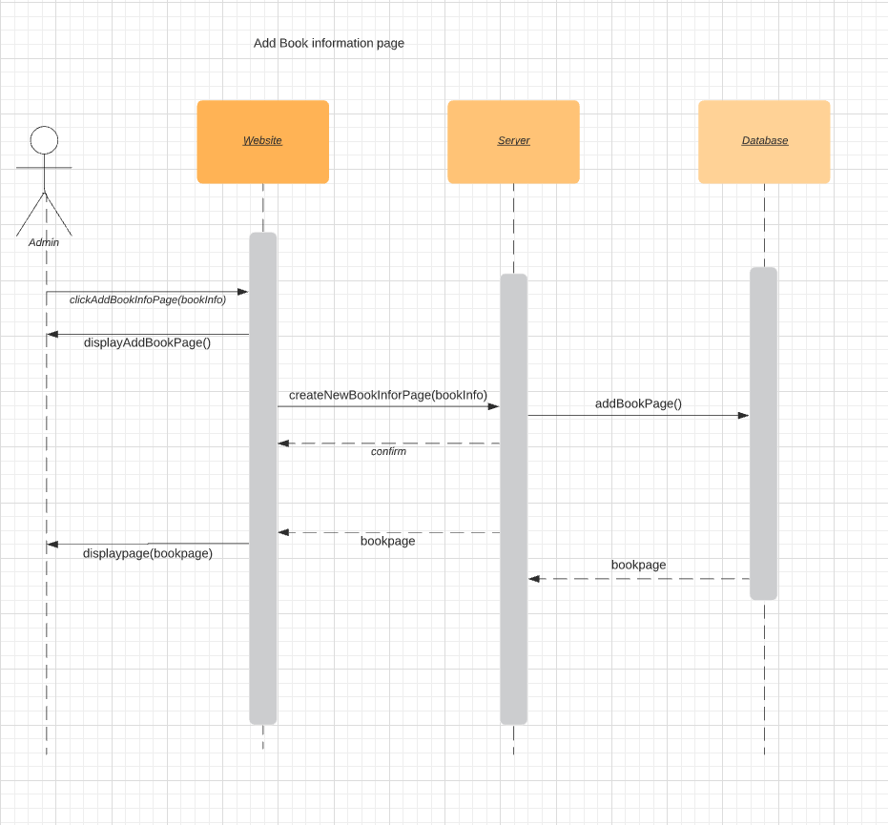

1. **Edit Books/Admin**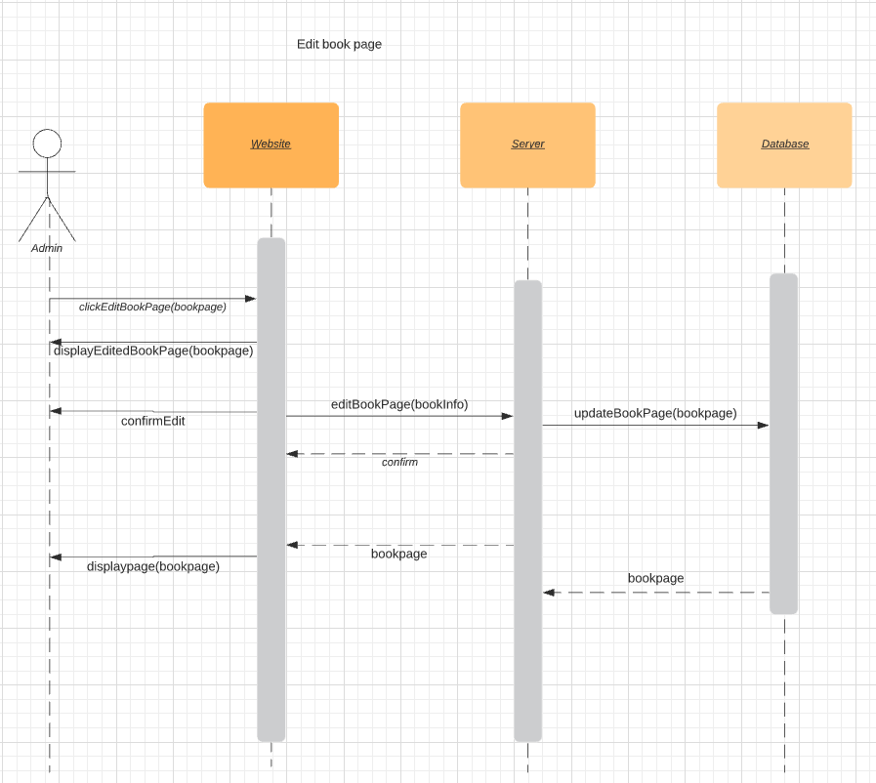

**16. Remove Book/Admin**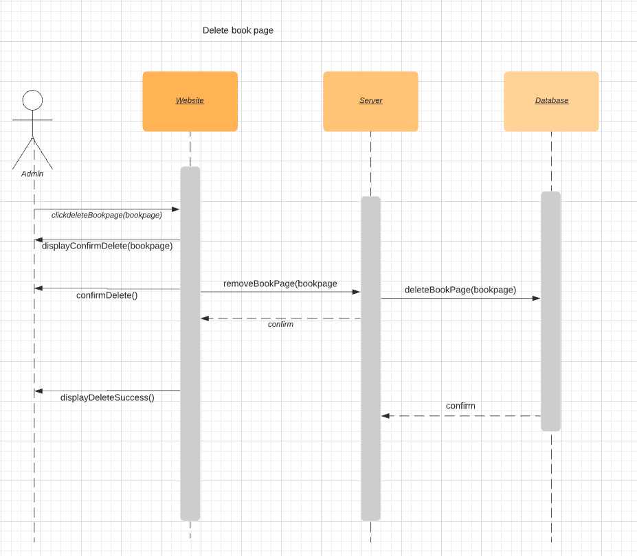

**7. Class diagram:**

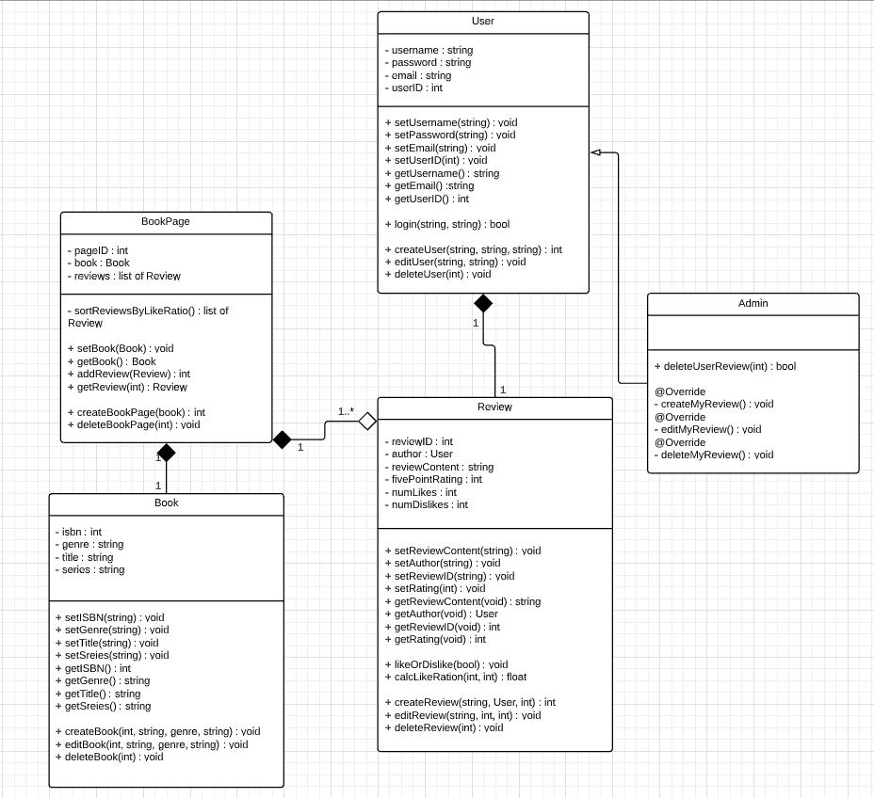

**8. Architectural design** - Model-View-Controller (MVC) pattern (similar to Figure 6.6)

